Capstone Project - The Battle of Neighborhoods (Week2) Report
Table of contents:
- Introduction: Business Problem
- Data
- Methodology
- Analysis
- Results and Discussion
- Conclusion

Introduction: Business Problem
This project aims to select the safest borough in London based on the total crimes, explore the neighborhoods of that borough to find the 10 most common venues in each neighborhood and finally cluster the neighborhoods using k-mean clustering.This report will be targeted to people who are looking to relocate to London. Inorder to finalise a neighborhood to hunt for an apartment, safety is considered as a top concern when moving to a new place. If you don’t feel safe in your own home, you’re not going to be able to enjoy living there. The crime statistics will provide an insight into this issue.We will focus on the safest borough and explore its neighborhoods and the 10 most common venues in each neighborhood so that the best neighborhood suited to an individual's needs can be selected.
Data:
- Based on definition of our problem, factors that will influence our decision are:
- The total number of crimes commited in each of the borough during the last year.
- The most common venues in each of the neighborhood in the safest borough selected.
Following data sources will be needed to extract/generate the required information:
- Part 1: Preprocessing a real world data set from Kaggle showing the London Crimes from 2008 to 2016: A dataset consisting of the crime statistics of each borough in London obtained from Kaggle.
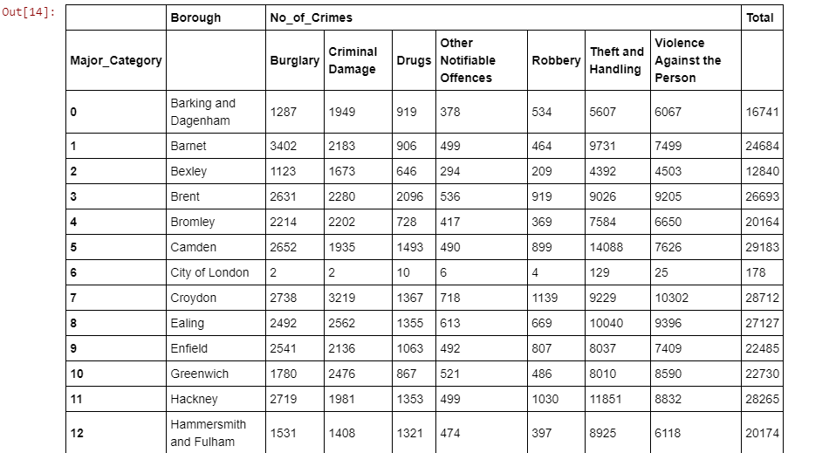

- Part 2: Scraping additional information of the different Boroughs in London from a Wikipedia page: More information regarding the boroughs of London is scraped using the Beautifulsoup library.
- Part 3: Creating a new dataset of the Neighborhoods of the safest borough in London and generating their co-ordinates: Co-ordinate of neighborhood will be obtained using Google Maps API geocoding.
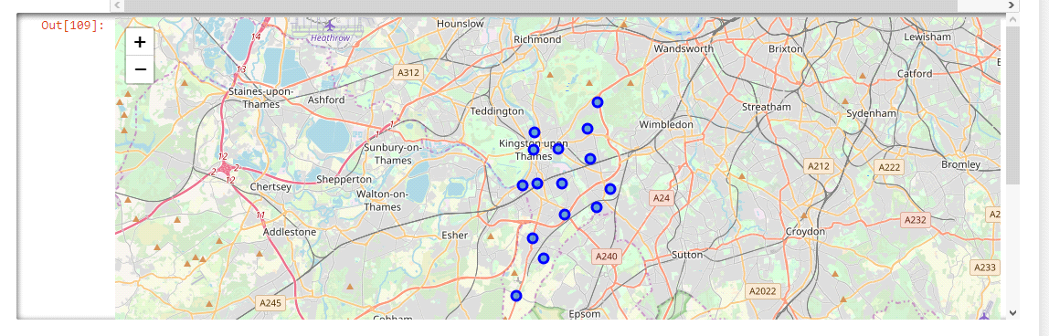
Visualize the Neighborhood of Kingston upon Thames Boroug

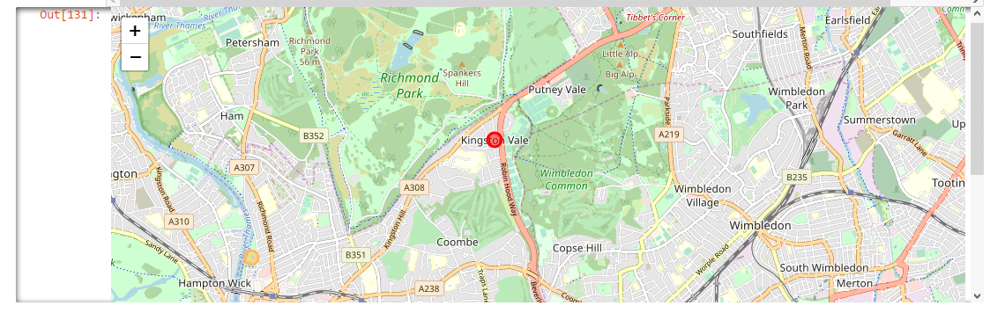
Visualize the clusters

Methodology:
The methodology in this project consists of two parts:
- Exploratory Data Analysis: Visualise the crime rates in the London boroughs to idenity the safest borough and extract the neighborhoods in that borough to find the 10 most common venues in each neighborhood.
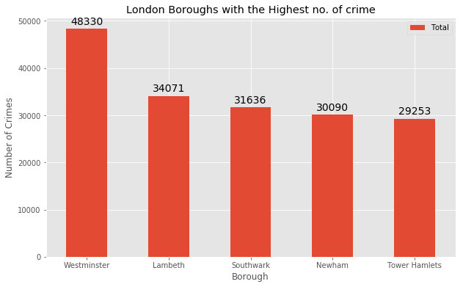
Visualize the five boroughs with the highest number of crimes

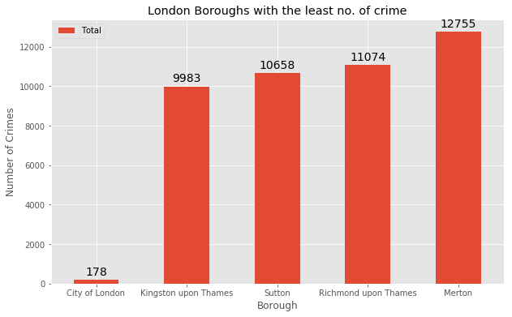
Visualize the five boroughs with the least number of crimes

- Modelling: To help people find similar neighborhoods in the safest borough we will be clustering similar neighborhoods using K - means clustering which is a form of unsupervised machine learning algorithm that clusters data based on predefined cluster size. We will use a cluster size of 5 for this project that will cluster the 15 neighborhoods into 5 clusters. The reason to conduct a K- means clustering is to cluster neighborhoods with similar venues together so that people can shortlist the area of their interests based on the venues/amenities around each neighborhood.
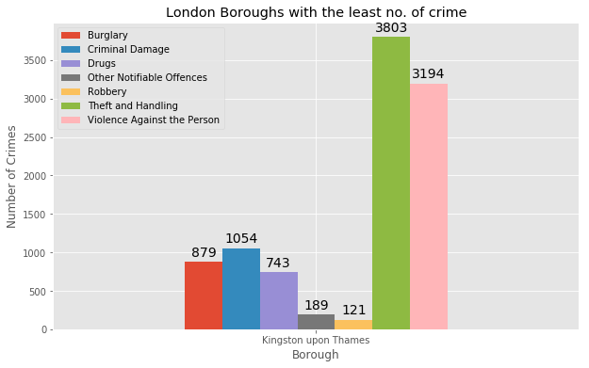
Visualizing different types of crimes in the borough 'Kingston upon Thames'

Analysis:
Analyse each of the clusters to identify the characteristics of each cluster and the neighborhoods in them.We can conclude that Kingston upon Thames is the safest borough when compared to the other boroughs in London.
Results and Discussion:
The aim of this project is to help people who want to relocate to the safest borough in London, expats can chose the neighborhoods to which they want to relocate based on the most common venues in it. For example if a person is looking for a neighborhood with good connectivity and public transportation we can see that Clusters 3 and 4 have Train stations and Bus stops as the most common venues. If a person is looking for a neighborhood with stores and restaurants in a close proximity then the neighborhoods in the first cluster is suitable. For a family I feel that the neighborhoods in Cluster 4 are more suitable dues to the common venues in that cluster, these neighborhoods have common venues such as Parks, Gym/Fitness centers, Bus Stops, Restaurants, Electronics Stores and Soccer fields which is ideal for a family.
Conclusion:
This project helps a person get a better understanding of the neighborhoods with respect to the most common venues in that neighborhood. It is always helpful to make use of technology to stay one step ahead i.e. finding out more about places before moving into a neighborhood. We have just taken safety as a primary concern to shortlist the borough of London. The future of this project includes taking other factors such as cost of living in the areas into consideration to shortlist the borough based on safety and a predefined budget.

